**Volunteerism Motivation**

Nicolas Dolce

Department of Psychology, The College of New Jersey

PSY492: Senior Collaborative Research

Dr. Kirnan

April 29, 2022

**Abstract**

This study discusses the motivations behind volunteerism across multiple sects, honing in on one sector of animal assisted intervention (AAI). The broader volunteer literature provides information on who volunteers and why they volunteer. This study analyzed animal handler volunteer demographics, motivation, and commitment in the organization Pet Partners. The method consisted of a 10-minute online survey comprised of the Volunteer Function Inventory (VFI) which is an established measure of volunteer motivation and supplemental items. The participants were 470 Pet Partners animal handler volunteers for demographic questions and 669 participants for VFI sub-score items. Demographics revealed that animal handler volunteers are predominantly female, white, older, married, well educated, and financially secure. A large percent of the sample was also retired. Animal handler volunteers were motivated mostly by altruism (values function on the VFI) and least by career opportunities. The VFI should be modified to include social items including making new friends as well as spending time with current friends. This change is suggested to broaden the scope of reasons. These volunteer results are similar to the literature with animal assisted therapy (AAT) and dog specific AAI groups.

*Key Words:* motivation, volunteer, dogs, AAI, animals, species

**Volunteerism Motivation**

Nonprofits make up 5.9% of Gross Domestic Product (GDP) (Independent Sector, 2022). Over 60 million people volunteered through or for an organization at least once between 2014 and 2015. During the same time period volunteers spent a median of approximately 50 hours on volunteer activities. While volunteerism has been studied extensively, little research has been conducted on specific subgroups of volunteers.

This paper investigated volunteering in the specific area of animal handlers participating in animal assisted interventions (AAI). AAIs are activities that involve interaction with a friendly animal with the goal of improving human well-being. This paper explored the literature on general volunteerism. This research aimed to develop an understanding of this unique volunteer position through an analysis of survey data.

**Volunteers and Volunteering**

*Demographics of Volunteers*

The rate of volunteering varies across several demographic factors. Men volunteered at a rate of about 22% while 28% of women volunteered People who were most likely to volunteer tended to be older, between 35 and 54. Volunteerism varies by race with Whites volunteering at 26%, Blacks at 19%, Asians at 18%, and Hispanics at 16%. Individuals who are married are more likely to volunteer (30%) than those who had never married (20%). Other marital statuses comprised of 20% participation. People with more education have higher volunteer rates than those who are less educated. They are also more likely to volunteer for multiple organizations (U.S. Bureau of Labor Statistics, 2016). Demographics are one piece of information for volunteers, but another avenue to explore is their motivation.

Gidron (1978) studied volunteers assisting paid workers at mental health institutions. Survey data was collected from 317 respondents. Women were 84% of respondents. A small 22% were 24 years old or younger, 26% were 25-54, and 55 years or older had 52%. Only a few people also worked a salary job in addition to volunteering. It was found that 46% of people worked at the respected institution for 4 years or more. It was also concluded that the older one was, the greater the chance that they would stay.

*Theories on Volunteer Motivation*

It is important to understand volunteer motivation so organizations can better advertise to volunteers and make volunteering more appealing to people. Greater appeal should increase the organizations’ ability to attract and retain their volunteers.

Tapp and Spanier (1973) conducted a study comparing the attitudes and motivations of volunteer phone counselor college students and regular college students. The results showed that the volunteers were more altruistic in their motivations for volunteering. Howarth (1976) studied 374 female volunteer responses to a survey to gain insight into volunteer motivation or volunteer personality aspects. Howarth (1976) concluded that one avenue is that people volunteer due to their conscience giving them anxiety and that by volunteering their anxiety is reduced. Gidron (1978) concluded that volunteers are altruistic, but seek socialization from the organization when they volunteer, and people may leave if that is not provided.

The Two-Factor model was introduced by Horton-Smith (1981) as he developed a two-factor model for understanding volunteer motivation. He distinguishes between altruistic motives (feeling good about helping others) and egoistic motives (tangible rewards). These can also be seen as intrinsic and extrinsic, respectively. Frisch and Gerrard (1981) studied the characteristics and motives of Red Cross volunteers through a questionnaire. The sample was mostly white, well educated, middle-aged, and female. Volunteers were motivated primarily due to altruism, especially the older people. They found that people were motivated to volunteer by either altruistic motives (concern for others) or egoistic motives (concern for themselves). Fitch (1987) surveyed 76 college students in order to study characteristics, motivations, and specifically the interrelationship between the reasons for volunteering and demographic variables. Results demonstrated that participants were mostly women, were both altruistically and egoistically motivated, and started volunteering at an early age. Another earlier theory for why people volunteer is the altruism-egoism debate. This means that primary motives for volunteering fall into a spectrum between these two categories based on responses to individual questions (Collins, 2014).

Previous theories on volunteerism include that continuing to help is influenced by whether the particular activity fits with the helper's own needs and goals, and that different volunteers have different types and number of goals. Furthermore, there is the functional approach which is a motivational perspective that starts, directs, and maintains volunteerism action (Esmond, 2004). Katz (1960) also states how people can engage in the same goals, but for different reasons. Another aspect of volunteer motivation is if the volunteering activity satisfies the concerns of the volunteer, since they may be more passionate about it (Clary & Snyder, 1999). This would in turn increase motivation since it is something they innately care about.

Clary developed the theory by combining aspects from Katz’s theory above (Katz, 1960) and Smith et al. (1956). Clary wanted to include aspects of psychodynamic theory, Gestalt psychology, self-psychology, the behaviorist perspective of human nature, as well as ego (Clary et al, 1998).

According to Clary et al. (1998) there are six types of motivations including protective motives (ego defense mechanism), values (altruism and being humanitarian), career (advancing one’s career), social (socializing), understanding (gaining knowledge, skills, and abilities), and enhancement (growing the ego). These attributes are seen in Clary’s Volunteer Functions Inventory (VFI), refer to the Appendix. The VFI is used in research to measure volunteer motivational factors.

Esmond (2004) offered a theory involving similar components in his Volunteer Motivation Inventory (VMI). In Esmond’s study both the VFI and VMI were statistically compared and the VMI had less overall reliability and validity due to some sections. The VFI’s Understanding measure was superior than that of the VMI’s Personal Growth measure. Clary et al.’s (1998) VFI was also more compact and clearer, thus it was the better choice to use for the current research.

Another motivational theory includes the obtainment of intrinsic values or internal rewards such as altruism, career advancement, and social (Esmond, 2004). A separate theory is that the volunteers try to gain extrinsic or external values such as occupational, control, and power (Haug & Gaskins, 2012). One could find a binary system of intrinsic and extrinsic rewards limiting; therefore, this paper relies on Clary’s six prong theory.

**Diverse Sectors from Previous Research on Volunteerism**

Volunteers appear in a variety of settings and differ in both motivation and demographics. Three studies of unique volunteer sectors are presented below. Differences are also noted.

*EMT Volunteers*

In this article the researchers investigated why people volunteer for EMT positions, why they stay and why they leave. The literature review focused mainly on values. Intrinsic values include altruism. Extrinsic values include external goals, occupational goals, and control or power. People left EMT positions due to administrative mental exhaustion such as long hours, copious paperwork, minimal administrative support and hospital co-workers’ attitudes. People also left due to clinical psychological trauma, but this contributed to a lesser extent. Examples included chronic exposure to tragedy, physical dangers, and pressure to perform correctly in uncertain circumstances. Participants were EMT volunteers from two distinctive locations, one urban and one rural who completed surveys. Respondent demographics for EMTs in this study included gender, race, and age from people in group A and B from two different locations, one urban and one rural. Respondents were primarily Caucasian (A, 90% and B, 82%), aged 30 or under (A, 48% and B, 50%), and male (A, 58% and B, 55%). The most important motivating factor related to EMT volunteerism in both locations was the desire to help others, followed by the desire to begin a career in health care or public safety. Very few volunteers were concerned with making new friends or accumulating community service hours for education. Motivations for volunteering as an EMT can be categorized in the verbiage of altruism and career advancement. To retain these volunteers, more flexible hours and shifts are needed in addition to guaranteed free training (Haug & Gaskins, 2012). The concept of free training could also be applied to dog handlers since they have to pay for dog training, certifications, and veterinary visits.

*AIDS Patient Volunteers*

The researchers were trying to learn more about volunteer motivation and retention by studying AIDS patient helper volunteers. Demographic information included most participants were white and well educated. There was great variability in terms of both age and annual household income. By sex, 59% were women and 41% men. The mean age was 39 and 49% of people had an annual household income of $20,001 to $50,000 (Omoto & Snyder, 1993).

People quit volunteering in this group due to being stigmatized, having uncomfortable feelings, or feeling embarrassed. People wanted to volunteer mostly due to a personal relation with HIV (60%) and wanting to give back to the community. This could also relate to dog volunteers if they are serving clients who are stigmatized. An example of this could be individuals with mental health issues. This may also be a reason for quitting since dog volunteers could be stigmatized as having a mental health issue, since they are involved with the program. Volunteers likely to serve the longest had motivations of esteem enhancement and personal development.

*Animal-Assisted Therapists* (*AAT) Volunteers*

The researchers studied motivation and retention in a specific volunteer group, the AAT. Fifteen animal-assisted therapists volunteering previously or at the time were recruited from Rhode Island and New Hampshire. Participant ages ranged from 19-74. The mean participant age was 56, which is much older than the EMT or AIDS volunteers. Most participants (46.7%) were in their 50’s. All 15 participants identified as White. Seventy-three percent were married and 86.7% owned their own home. People who were employed part-time consisted of 33%, 26.7% worked full-time and 20% were retired. All educational levels were represented, but the majority of people, 46.7% had a graduate degree from college. The number of participants who also reported completing other voluntary activities was 66% (Collins, 2014). Negative aspects of volunteering appeared to be taking away time or money from the participants. For motives, the participants rated the Values function (altruism) as the number one motivation in the Volunteer Motivation Index (VMI) (Collins 2014).

*Comparative Analysis from the above Three Volunteer Groups*

A common theme from the studies by Collins (2014), Haug and Gaskins (2012), and Omoto and Snyder (1993) were that the volunteers were mostly White. Fifteen out of fifteen animal-assisted therapists, 90% and 82% for EMT groups, and a qualitative description of “majority” respectively for AIDS volunteers. Barriers to volunteering included stigma, time, and money. In terms of the sex or gender demographic, EMT volunteers were mostly male. This may have to do with the job role fitting gender stereotype or image, or that this job acts as a stepping stone into the medical field, which is male dominated. Collins (2014) unfortunately did not report a sex or gender variable in the participant section. The AIDS volunteers were comprised of more women. To summarize the motives, altruism can be seen as the foundation and roots. While altruism is common in all three, there are differences such as the EMT volunteers focusing on career strongly as well as having a lower age. This supports the need to study volunteer sectors separately since motives and demographics may differ.

**Definition of AAI**

Animal-assisted interventions (AAI) is a broad term for animal-assisted therapy (AAT), animal-assisted education (AAE), and animal-assisted activities (AAA). These therapies use animals to help people in a variety of ways (Pet Partners, 2022). For example, human-animal attachments help clients to achieve therapeutic gains. Oxytocin released when spending time with the animals inhibits stress (Serpell et al., 2017). Beetz et al. (2011) studied children aged 7-12 with insecure attachment with social support by dog, adult, or toy dog during a stressor. Results were lower cortisol levels in the group supported by a dog with a strong connection of lower cortisol with physical contact with dog.

**Pet Partners**

Pet Partners is a non-profit engaged in AAI with volunteers and animal species. The volunteers serve many populations with a variety of animals which helps them to fortify the impact made. The goal of Pet Partners is to help people in the community through AAT, AAA, and AAI. Dogs make up 94% of the teams in the Therapy Animal Program. The other 6% is comprised of horses, cats, alpacas, llamas, guinea pigs, rats, birds, rabbits, and pigs. Pet Partners’ teams visit a variety of settings. Animals are tested and certified through Pet Partners when registering with them. They offer handler training, liability insurance coverage, volunteering opportunities, and access to Pet Partners’ online courses for free or discounted prices.

In today’s stressful world, there is an increased interest in natural remedies such as being in nature or spending time with animals. As Michael J. McCulloch, MD and co-founder of Pet Partners once said, “In an age of research when it is tempting to reduce emotions to biochemical reactions and to rely heavily on the technology of medicine, it is refreshing to find that a person’s health and well-being may be improved by prescribing contact with other living things” (Pet Partners, 2022).

Dalton et al. (2020) stated how the human animal bond helps people in a variety of settings. Specifically, animal assisted intervention (AAI) is used for patient’s care in diverse settings to reduce symptoms of pain, anxiety, and stress. Pet Partner volunteers work internationally within the sectors of medical settings, physical wellness, mental wellness, education, and senior adults.

**The Research Process**

*Initial Observations*

Many dog-specific AAI studies report a higher percent of female than male volunteers. Binfet (2017), showed that 93% of the community volunteers in the analyzed sample were female and middle aged in his study of Canine Therapy on University students. Charles and Wolkowitz (2019), showed that their Pets as Therapy Program (PAT), a UK charity, was set up by women and mostly run by women. The visitors were also mostly women. One may speculate that this is so due to the possibility of men not wanting to hurt their images. Furthermore, Grajfoner et al. (2017) compared 85 female volunteers to only 47 male volunteers in their research on the effect of dog-assisted intervention on student well-being, mood, and anxiety.

*Research Questions or Hypothesis*

This research explored volunteerism in a unique sector of volunteers, animal handlers.

The aim of the current research was to investigate the demographics and motives of volunteers for animal assisted volunteering events utilizing a survey distributed to Pet Partner volunteers. From observation and research, it was hypothesized that for the Pet Partner sample most of the volunteers will be White, middle-aged women who are educated, and financially stable. While no hypotheses are proposed for employment or marital status, these factors will also be analyzed. Participant motives for volunteering are hypothesized to be due to altruism. Most will be White because due to observation and research it appears that Whites are more culturally accepting of dogs and/or are more privileged living in America today in 2022, therefore having more time to donate.

**Method**

**Participants**

The participants were 470 Pet Partners volunteers for demographic questions and 669 participants for VFI sub-score items. This difference in sample size is due to ongoing data collection. Demographics will appear in the Results section.

**Materials**

*The VFI*

Authors have used and respected the VFI. Switzer et al. (1999) studied the motivations of medical students to volunteer across gender and compared this data to other volunteers. These authors utilized the VFI and found high reliability and validity. The VFI is a 30-item survey with a 7-point Likert scale. The anchors in the scale ranged from 1-not at all important and accurate to 7-extremely important/accurate.

*The Survey*

The survey had three sections, commitment, motivation, and demographics. The survey attempts to measure level of commitment through various items that asked about years volunteering and average hours per week. The survey investigates motivation through three questions, an open-ended item, a rating scale that included motivators not in the VFI, and the VFI. Even though Clary et al. (1998) provided a solid foundation for theories of volunteerism, after reviewing the VFI survey items one could conclude that the social category was not well represented as being completely social since it left out making new friends. It only included spending time with current friends who volunteer. Due to this, the survey used in the current study included additional motivational items to supplement the VFI. The final section captures respondent demographics. Animal specific items were added in addition to the social items stated previously. Animal specific items included what type of animal was used and how many were used currently and in the past per volunteer. The idea to include these came from Collins, 2014.

Commitment questions were added to try to gain an understanding of how volunteers varied in their level of commitment. We are also asking about demotivators because there is not much information on this in the literature. Items include reasons why they have left a site or reasons they do not volunteer more hours. Questions on the demographic portion included typical factors such as gender, race, and age as well as additional information on household or employment, which may capture many factors associated with volunteering. Refer to Appendix.

**Procedure**

The survey was administered electronically. It takes about ten minutes to complete. Pet Partners emailed the survey link to 7,318 animal handlers in the organization from all around the world.

**Results**

*Demographic Items*

Various demographic factors were compared to the existing literature or other relevant samples and tested for significance where possible. The average age for the volunteer sample was higher (*M*=61.65, *SD*= 12.28) than reported in Collins (2014) where (*M*=56), *t*(447) = 9.74, *p<.*001*.*

For gender, the proportion of females in our research sample was significantly higher, 87.5%, than reported by Grajfoner et al. (2017) where 64.4% were women, *Z* = 10.5, *p<.001.*

For gender in the Binfet (2017) sample, the percent female was 93%. The proportion of females in our research sample was significantly lower (87.5%), *Z* = -4.7, *p<.001.*

For education, Collins (2014) reported 46.7% had a graduate degree from college. The valid percent in this study was lower at 32.5%. To test statistical significance a Z proportion test was conducted and yielded *Z*=-6.17, *p*<.001.

For financial status, 51% of the sample in the current study, had a household income of $100,000 or more. According to the 2020 U.S Census, the median income in the United States is $67,521(United States Census Bureau, 2020). Clearly, pet volunteering is for more financially privileged individuals.

For marital status, data reported that 66.6% were married. Collins (2014) reported 73.3% were married yielding *Z*=-3.28, p<.001. For marriage in America, the relevant comparison was 53% in 2019 (Fry et al., 2021). By comparison, the 66.6% in the current study was significantly higher with *Z=*-6.25, p<.001. Refer to Figure 1.

In this sample, 51.9% were retired. The value may be an underestimate due to survey selection option error, since some could be retired and working part time, but to the response format allowed for only one response rather than a “check all that apply”. Collins (2014) reported 20% of people were retired *Z*=17.29, p<.001.

For race, 98.2% were White whereas Collins (2014) reported 100% White of her 15 subjects yielding *Z*=2.77, p<.001. Hence, Collins (2014) had more Whites than the current study, at a statistically significant amount. Following an analysis of participant demographics, sub scores from the VFI and select individual motivation items were explored.

*Motivation Items*

The altruism factor, was represented in the values sub-score on the VFI. The mean for the values measure was 26 and was the highest of all sub scores. Refer to Figure 2. The Greenhouse-Geisser correction was applied to a repeated measures ANOVA and revealed that the mean sub-scores for the VFI differed statistically significantly (*F*(3.98, 3024.14)=1339.42, *p*<.001). Bonferroni post hoc analysis reported statistically significant differences between all possible pairs of sub-scores.

The difference in gender between males and females was significant on the four items asterisked in Table 1. For “the experience of volunteering with my pet”, women valued it more than men. For “volunteering continues a family tradition”, men valued this item more than women. For “strengthen relationship with my pet” item, women valued it more. Last, for the “Have fun” item, females valued the item more.

**Discussion**

The hypothesis about gender was supported since there was a valid percent of females of 87.5%. The hypothesis for age was incorrect since the mean age was 61.65, thus not middle aged. The results support the hypotheses of a racially white, educated, financially privileged, and altruistically motivated population. These attributes fit in with previous literature due to the unpaid nature of volunteers in an economically competitive world. Earlier demographic finding comparisons can be viewed in the results section with statistical comparison to previous literature. For motivation comparison, according to Collins (2014) the values (altruism) function also had the highest mean out of all other factors at 4.5. The lowest factor was protective at 2.0. The protective function describes when a volunteer tries to escape negative feelings about themselves by volunteering. The lowest factor in this study turned out to be career at 6.0. Refer to Figure 2. Unfortunately, Collins (2014) did not investigate gender differences.

Limitations included incoming data and not giving enough options for the working question of part time, full time, retired, partially retired, etc. Suggestions for future study include surveying a different group instead of animal handlers. Finally, this paper investigated motivation, demographics, and commitment of animal handlers in the organization of Pet Partners.

**References**

Beetz A., Kotrschal K., Hediger K., Turner D., Uvnäs-Moberg K. (2011). The effect of a real dog, toy dog and friendly person on inseucrely attached children during a stressful task: an exploratory study. *Anthrozoos* 24, 349–36810.2752/175303711X13159027359746

Binfet, J.T., (2017). The effects of group-administered canine therapy on university students’ wellbeing: A randomized controlled trial. *Anthrozoös, 30*(3), 397-414. https://doi.org/10.1080/08927936.2017.1335097

Charles, N & Wolkowitz, C. (2019). Bringing dogs onto campus: Inclusions and exclusions of animal bodies in organizations. *Gender, Work, and Organization*, *26*(3), 303–321. https://doi.org/10.1111/gwao.12254

Clary, E. G., & Snyder, M. (1999). The motivations to volunteer: Theoretical and practical considerations. *Current Directions in Psychological Science*, *8*(5), 156–159. http://www.jstor.org/stable/20182591

Clary, E. G., Snyder, M., Ridge, R. D., Copeland, J., Stukas, A. A., Haugen, J., & Meine, P. (1998). Understanding and assessing the motivations of volunteers: A functional approach. *Journal of Personality and Social Psychology, 74*, 1516-1530.

Collins, K.V, "Animal-Assisted Therapy: Motives and Rewards" (2014). Honors Theses and Capstones.175. https://scholars.unh.edu/honors/175

Dalton, K.R, Waite, K. B., Ruble, K., Carroll, K. C., DeLone, A., Frankenfield, P., Serpell, J. A., Thorpe, R. J., Morris, D. O., Agnew, J., Rubenstein, R. C., & Davis, M. F. (2020). Risks associated with animal-assisted intervention programs: A literature review. *Complementary Therapies in Clinical Practice*, *39*, 101145–101145. https://doi.org/10.1016/j.ctcp.2020.101145

Esmond, J. (2004). Developing the volunteer motivation inventory to assess the underlying

motivational drives of volunteers in western Australia. *Community Link and Network (CLAN) WA Inc., 1-82.*

Fitch, R.T. (1987). Characteristics and motivations of college students volunteering for

community service. *Journal of College Student Personnel, 28*, 424-431.

Frisch, M.B., & Gerrard, M. (1981). Natural helping systems: Red Cross volunteers.

*American Journal of Community Psychology, 9*, 567-579.

Fry, R., & Parker, K. (2021, October 5). *Rising Share of U.S. Adults Are Living Without a Spouse or* *Partner*. Pew Research Center. Retrieved April 29, 2022, from https://www.pewresearch.org/social-trends/2021/10/05/rising-share-of-u-s-adults-are-living-without-a-spouse-or-partner/#:~:text=Americans'%20marital%20and%20living%20arrangements,to%209%25%20in%202019).

Gidron, B. (1978). Volunteer work and its rewards. *Volunteer Administration, 11*, 18-32.

Grajfoner, D., Harte, E., Potter, L. M., & McGuigan, N. (2017). The effect of dog-assisted intervention on student well-being, mood, and anxiety. *International Journal of Environmental Research and Public Health*, *14*(5), 483, 1–9. https://doi.org/10.3390/ijerph14050483

Haug & Gaskins, J. N. (2012). Recruiting and retaining volunteer EMTs: From motivation to practical solutions. *International Journal of Sociology and Social Policy*, *32*(3/4), 197–213. https://doi.org/10.1108/01443331211214767

*Health of the U.S. Nonprofit Sector*. (n.d.). Independent Sector. Retrieved March 10, 2022, from https://independentsector.org/nonprofithealth/

Horton-Smith, D. (1981). Altruism, volunteers, and volunteerism. *Journal of Voluntary*

*Action Research*, *10*, 21-36.

Howarth, E. (1976). Personality characteristics of volunteers. *Psychological Reports, 38*, 855-

858

*Income and Poverty in the United States: 2020*. (2020). United States Census Bureau. Retrieved April 26, 2022, from https://www.census.gov/data/tables/2021/demo/income-poverty/p60-273.html

Katz, D. (1960). The functional approach to the study of attitudes. *Public Opinion Quarterly*, *24*(2), 163–204. https://doi.org/10.1086/266945

Omoto, A. M., & Snyder, M. (1993). AIDS volunteers and their motivations: Theoretical issues and practical concerns. Nonprofit Management and Leadership, 4(2), 157-176. https://doi.org/10.1002/nml.4130040204

*Pet Partners*. (n.d.). Pet Partners. Retrieved March 16, 2022, from https://petpartners.org/

Serpell, J., McCune, S., Gee, N., & Griffin, J. A. (2017). Current challenges to research on animal-assisted interventions. *Applied Developmental Science*, *21*(3), 223–233. https://doi.org/10.1080/10888691.2016.1262775

Smith, B., Bruner, J.S, White, R.W. (1956). Opinions and Personality.

*The American Political Science Review*, *50*(3), 916–917. https://doi.org/10.2307/1951587

Switzer, C. L., Switzer, G. E., Stukas, A. A., & Baker, C. E. (1999). Medical students’

motivations to volunteer. *Journal of Prevention and Intervention in the Community, 18*, 53-64.

Tapp, J.T. & Spanier, D. (1973). Personal characteristics of volunteer phone counselors. *Journal of Consulting and Clinical Psychology*, *41*(2), 245–250. https://doi.org/10.1037/h0035137

*Volunteering in the United States, 2015*. (2016, February 25). U.S. Bureau of Labor Statistics. Retrieved March 15, 2022, from https://www.bls.gov/news.release/volun.nr0.htm



____________________________________________________________________________________

*Note*. Asterisks show statistical significance.

Figure 1:

Figure 2:

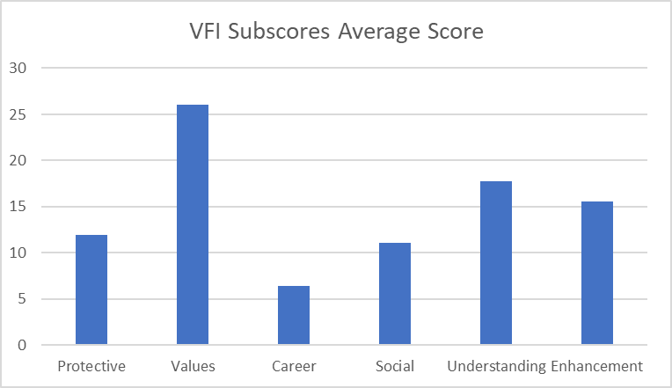

**Appendix**

*Volunteer Functions Inventory (VFI)*

**Scale**

Please indicate how important or accurate each of the 30 possible reasons for volunteering were for you in doing volunteer work. (1 = not at all important/accurate; 7 = extremely important/accurate).

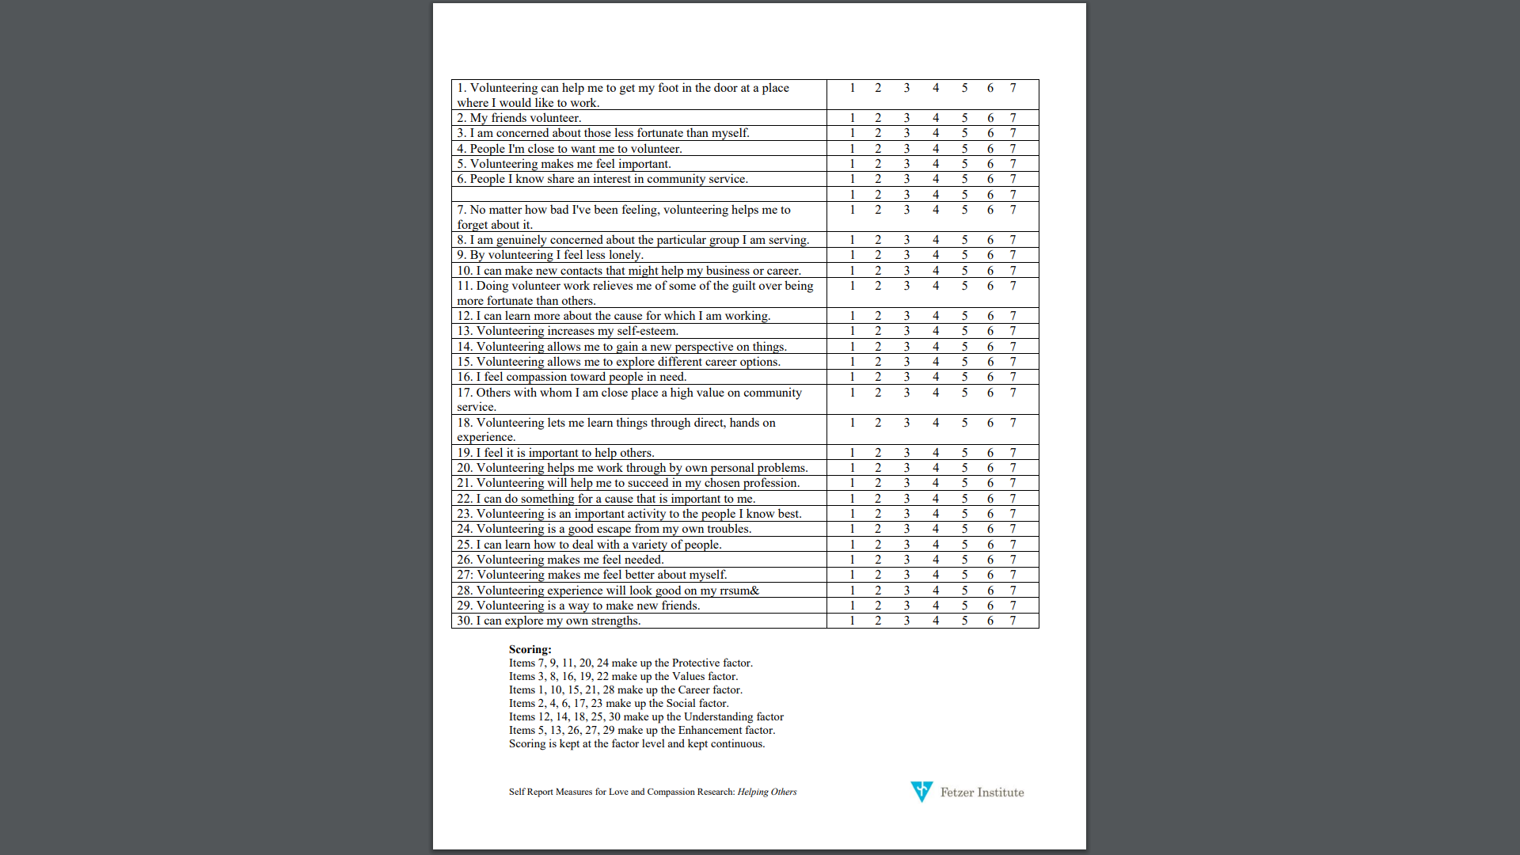

*VMI*

*Note*. These are the VFI survey questions. For the survey implemented, the group changed the Social factor items to better represent socializing.